Name – Shaurya Srinet

Reg No - RA2111032010006

Branch - CSE w/s in IoT

Class – T2

**Object Oriented Programming and Design**

**Assignment: Week 3**

1. Create a class named 'Student' with a string variable 'name' and an integer variable 'roll_no'. Assign the value of roll_no as '2' and that of name as "John" by creating an object of the class Student.

#include<iostream>

using namespace std;

class Student

{

public:

string name;

int roll_no;

}obj1;

int main()

{

obj1.name="John";

obj1.roll_no=2;

cout << obj1.name << endl;

cout << obj1.roll_no << endl;

return 0;

}

Input and Output

C:\Users\Lenovo\Pictures\Screenshots\Screenshot (308).png

2. Write a C++ program to illustrate the concept of class and object creation. (Ask students to create a class, methods and invoke them inside main method).

#include<iostream>

using namespace std;

class Trial

{

public:

string name,grade;

int roll_no;

}obj1,obj2;

int main()

{

obj1.name="Jack";

obj1.grade="A++";

obj1.roll_no=7;

obj2.name="Rosey";

obj2.grade="O";

obj2.roll_no=30;

cout << "Details of Object 1:" << endl;

cout << obj1.name << " " << obj1.roll_no << " " << obj1.grade << endl;

cout << "Details of Object 2:" << endl;

cout << obj2.name << " " << obj2.roll_no << " " << obj2.grade << endl;

return 0;

}

Input and Output

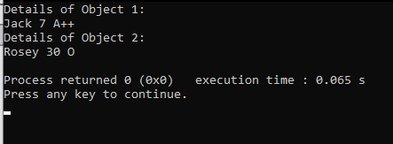

3. Write a C++ program to define a class Date that holds day, month and year as datamembers. Also write necessary member methods to

#include<iostream>

using namespace std;

class Date

{

public:

int day,month,year;

void read()

{

cout << "All entries in numbers please\n";

cout << " Enter the day: "; cin >> day;

cout << "\nEnter the month: "; cin >> month;

cout << "\nEnter the year: "; cin >> year;

return;

}

void print()

{

cout << "\nD/M/Y format: " << day << "/" << month << "/" << year << endl;

cout << "\nM/D/Y format: " << month << "/" << day << "/" << year << endl;

return;

}

void one()

{

cout << "Date after one week (D/M/Y): ";

if(day>=22)

{

if(day>=22 && month==2)

{

if(year%4!=0)

cout << (day+7)-28 << '/' << month+1 << '/' << year << endl;

else if((year%4==0 && year%10!=0)||((year%100==0)&&(year%4==0)))

cout << (day+7)-29 << '/' << month+1 << '/' << year << endl;

}

else if (month==4||month==6||month==9||month==11)

cout << (day+7)-30 << '/' << month+1 << '/' << year << endl;

else

cout << (day+7)-31 << '/' << month+1 << '/' << year << endl;

}

else

cout << day+7 << '/' << month << '/' << year << endl;

return;

}

}ob;

int main()

{

ob.read();

ob.print();

ob.one();

return 0;

}

Input and Output

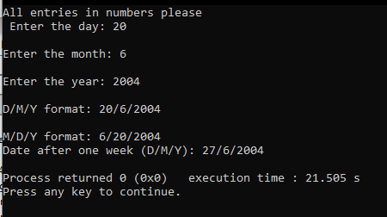

4. Define a class named Circle which can be constructed by a radius. The Circle class has two methods for computing perimeter and area, respectively.

#include<iostream>

using namespace std;

class Circle

{

public:

float peri(float r)

{

return 2*3.14*r;

}

float area(float r)

{

return 3.14*r*r;

}

}obj;

int main()

{

float r;

cout << "Enter radius of circle: ";

cin >> r;

cout << "\nCircumference: " << obj.peri(r);

cout << "\nArea: " << obj.area(r) << endl;

return 0;

}

Input and Output

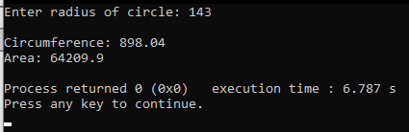

5. Write a C++ class which has two funtions get_Str and print_Str. get_Str accept a string from the user and print_Str print the string in upper case and lower case

#include<iostream>

#include<cstring>

using namespace std;

class strfunc

{

public:

void get_Str()

{

string str;

cout << "Enter a string" << endl;

getline(cin,str);

print_Str(str);

}

void print_Str(string str)

{

int i;

cout << "String in lower case: " << endl;

for(i=0;i<str.length();i++)

cout << (char)tolower(str[i]) << "";

cout << endl;

cout << "String in upper case: " << endl;

for(i=0;i<str.length();i++)

cout << (char)toupper(str[i]) << "";

cout << endl;

return;

}

}obj;

int main()

{

obj.get_Str();

return 0;

}

Input and Output

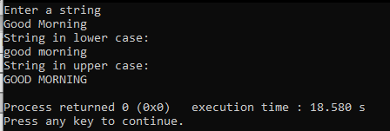

6. Write a program to print the area and perimeter of a triangle having sides of 3, 4 and 5 units by creating a class named 'Triangle' with a function to print the area and perimeter.

#include<iostream>

#include<math.h>

using namespace std;

class Triangle

{

public:

void peri(int a,int b, int c)

{

cout << "Perimeter: " << a+b+c << endl;

area(a,b,c);

}

void area(int a, int b, int c)

{

float s=((float)(a+b+c))/2.0;

float ar= pow(s*(s-a)*(s-b)*(s-c),0/5);

cout << "Area: " << ar << endl;

return;

}

}obj;

int main()

{

obj.peri(3,4,5);

return 0;

}

Input and Output

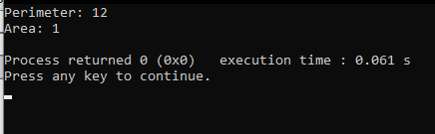

7. Print the average of three numbers entered by the user by creating a class named 'Average' having a function to calculate and print the average without creating any object of the Average class.

#include<iostream>

using namespace std;

class Average

{

public:

//static float a,b,c;

static void avg(float a, float b, float c)

{

cout << "Average: " << (a+b+c)/3 << endl;

}

};

int main()

{

float a,b,c;

cout << "Enter any three numbers:\n";

cin >> a >> b >> c;

Average::avg(a,b,c);

return 0;

}

Input and Output

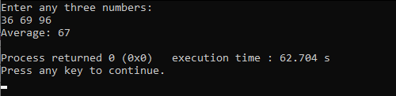

8. Develop a program of class Room with attributes length, breadth and height and its object room1 and room2 to calculate the area and volume of a room using function.

#include<iostream>

using namespace std;

class Room

{

public:

float l,b,h;

float Area()

{

return l*b;

}

float Vol()

{

return l*b*h;

}

}room1,room2;

int main()

{

cout << "Enter length of room 1: "; cin >> room1.l;

cout << "Enter breadth of room 1: "; cin >> room1.b;

cout << "Enter height of room 1: "; cin >> room1.h;

cout << "Enter length of room 2: "; cin >> room2.l;

cout << "Enter breadth of room 2: "; cin >> room2.b;

cout << "Enter height of room 2: "; cin >> room2.h;

cout << "Area of Room 1: " << room1.Area() << endl;

cout << "Volume of Room 1: " << room1.Vol() << endl;

cout << "Area of Room 2: " << room2.Area() << endl;

cout << "Volume of Room 2: " << room2.Vol() << endl;

return 0;

}

Input and Output

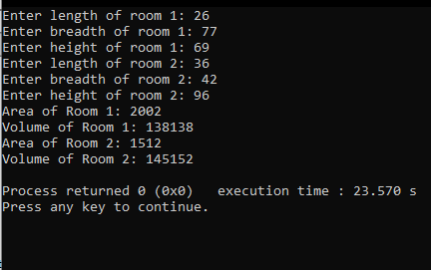

9. Design a program of class Car with some attributes and its object to print its attributes.

#include<iostream>

using namespace std;

class Car

{

public:

float price,weight,length,gc;

string ft,name;

void Display()

{

cout << endl;

cout << "Name of the car: " << name << endl;

cout << "Fuel Type of the car: " << ft << endl;

cout << "Price of the car: " << price << endl;

cout << "Weight of the car in kgs: " << weight << endl;

cout << "Length of the car in cm: " << length << endl;

cout << "Ground Clearance of the car in cm: " << gc << endl;

return;

}

}cust;

int main()

{

cout << "Enter the name of the car: "; getline(cin,cust.name);

cout << "\nEnter the fuel type of the car: "; cin >> cust.ft;

cout << "\nEnter the price of the car: "; cin >> cust.price;

cout << "\nEnter the weight of the car in kgs: "; cin >> cust.weight;

cout << "\nEnter the length of the car in cms: "; cin >> cust.length;

cout << "\nEnter the ground clearance of the car cms: "; cin >> cust.gc;

cust.Display();

return 0;

}

Input and Output

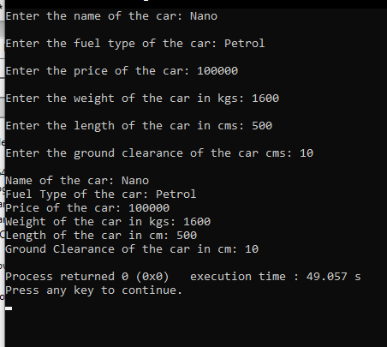

10. Find whether the student is eligible for the current year placement from the inputs student name, CGPA, gender (M/F), number of backlogs. Implement the above by using object oriented programming concept.

#include<iostream>

using namespace std;

class Placement

{

public:

string name;

char gender;

float cgpa,back;

bool isValid()

{

if(back==0 && cgpa>=6.0)

return true;

else

return false;

}

}stud;

int main()

{

cout << "Enter the name of student: "; getline(cin,stud.name);

cout << "\nEnter the gender of student (M/F): "; cin >> stud.gender;

cout << "\nEnter the CGPA of the student: "; cin >> stud.cgpa;\

cout << "\nEnter the number of backlogs of the student: "; cin >> stud.back;

if(stud.isValid())

cout << stud.name << " is eligible to sit for placement" << endl;

else

cout << stud.name << " is not eligible to sit for placement" << endl;

return 0;

}

Input and Output

